“Expert Cloud Consulting” -

SOP | Migration
09.December.2024
version 1.0
─
Contributed by Shreyash Patil
Approved by Atul Kumbhar(In Review)
Expert Cloud Consulting
Office #811, Gera Imperium Rise,
Hinjewadi Phase-II Rd, Pune, India – 411057

“Expert Cloud Consulting”

Migration of on-premises windows server to AWS cloud

1.0 Contents

1.0 Contents 1
2.0 General Information: 2
2.1 Document Purpose 2
2.2 Document References 2
2.3 Document Overview 3
3.0 Steps / Procedure 4
3.1: Installation of Discovery agent 4
3.2: Setting up replication template 4
3.3: Setting Up Post-Launch Actions 5
3.4: Installation of replication agent 5
3.5: Replication - Launch test instance to finalise cutover 7
3.5.1: Create or Edit a Launch Template: 7
3.5.2: Verify Launch Template: 8
3.5.3: Launch test instance: 8
3.5.4: Transitioning from Test Instance to Cutover Instance: 8
3.5.4: Finalize Cutover: 8
5.0 Annexure - I 9



2.0 General Information:

2.1 Document Purpose
This document provides a comprehensive guide for setting up a Windows Server with Active Directory (AD) to facilitate LDAP authentication for applications. It outlines the necessary steps to install and configure Active Directory Domain Services (AD DS), create user accounts, and enable LDAP over SSL for secure communications. This guide is intended for system administrators and IT professionals who are responsible for managing user authentication in a networked environment.

2.2 Document References
The following artifacts are referenced within this document. Please refer to the original documents for additional information.

Document | Filename / Url
Prerequisite for Application Migration Service | https://docs.aws.amazon.com/es_es/mgn/latest/ug/preparing-environments.html
Assessment (Application discovery service) -installation of discovery agent | https://docs.aws.amazon.com/application-discovery/latest/userguide/setting-up.html
Agent installation  -replication agent installation | https://docs.aws.amazon.com/mgn/latest/ug/windows-agent.html
Migration | https://docs.aws.amazon.com/mgn/latest/ug/quick-start-guide-gs.html

2.3 Document Overview
This document is structured to cover the following key areas:
- Prerequisites for Migration:
Provide a step-by-step guide for installing and configuring Active Directory on Windows Server..
- Assessment Using Application Discovery Service:
Steps to assess the current application environment using AWS Application Discovery Service, including the installation of the discovery agent to gather necessary data about on-premises applications.
- Installation Procedures:
Instructions for installing both the AWS Discovery Agent and the AWS Replication Agent on source servers. This section includes platform-specific guidelines for Windows and Linux environments.
- Migration Process:
A step-by-step guide to executing the migration using AWS Application Migration Service, including launching test instances, validating migrated applications, and performing the final cutover to AWS.
- Post-Migration Activities:
Recommendations for monitoring and optimizing applications post-migration, as well as decommissioning legacy systems in the on-premises environment.
- References:
  - Links to official AWS documentation and resources for further reading and troubleshooting throughout the migration process.
  - By following this document, teams can ensure a structured approach to application migration, leveraging AWS best practices to enhance operational efficiency and scalability in the cloud. Feel free to customize any part of this overview to better suit your organization's specific needs or style!

3.0 Steps / Procedure

3.1: Installation of Discovery agent
- Set AWS Migration Hub Home Region: Ensure that you have set your AWS Migration Hub home region
- Create IAM User: Create an IAM user with the AWSApplicationDiscoveryAgentAccess and AWSApplicationMigrationAgentPolicy policy attached.
- Download installer or find the latest download link here.
https://s3-us-west-2.amazonaws.com/aws-discovery-agent.us-west-2/windows/latest/AWSDiscoveryAgentInstaller.exe

- Run the installer

.\AWSDiscoveryAgentInstaller.exe REGION="HOME_REGION" KEY_ID="<ACCESS_KEY> " KEY_SECRET="SECRET_KEY " /q

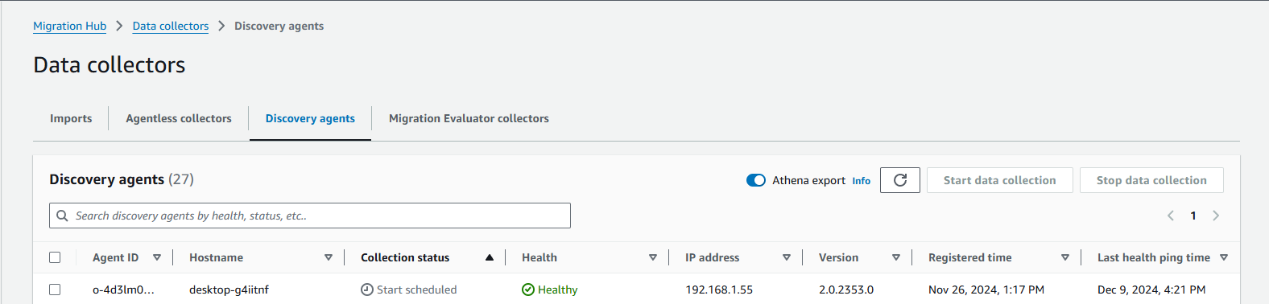

3.2: Setting up replication template
- Create the Replication Template:
During the initialization, you will have the option to create a replication template. This template is mandatory and will define how data replication is handled for each new server added.

- Configure Replication Settings:
Replication Server Instance Type: Choose the instance type that will be used for replication. Consider factors like bandwidth and performance requirements.
Replication Frequency: Set how often data should be replicated (e.g., every few seconds).

- Edit or Modify Replication Template
Here, you can adjust settings such as instance types, replication frequency, and other parameters as needed.
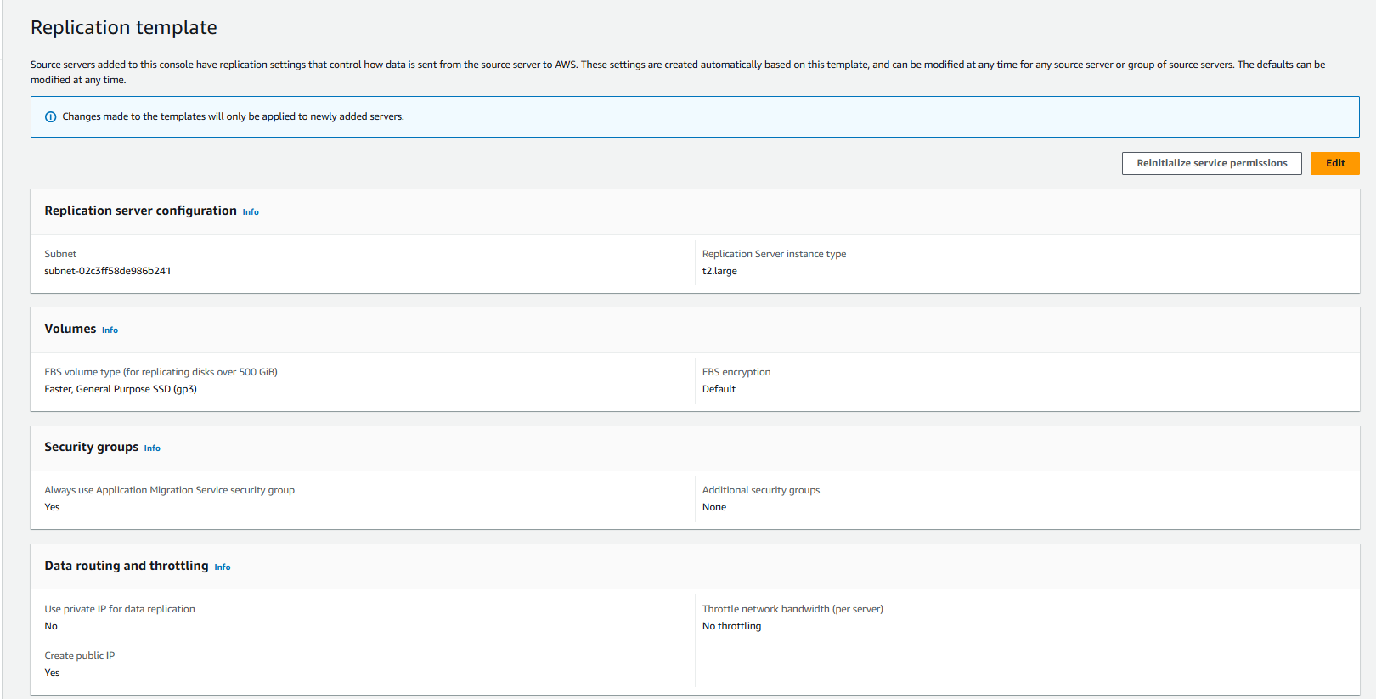

3.3: Setting Up Post-Launch Actions
- Activate Post-Launch Settings
select Post-launch settings template.
- Edit Post-Launch Settings:
Click on Edit.
In the dialog that appears, toggle the option for Install Systems Manager agent and allow executing actions on launched servers.
- Click on Save template at the bottom of the page to apply your changes.

3.4: Installation of replication agent

https://aws-application-migration-service-hashes-us-east-1.s3.us-east-1.amazonaws.com/latest/windows/AwsReplicationWindowsInstaller.exe.sha512

- Run as Administrator: Right-click on AwsReplicationWindowsInstaller.exe and select "Run as Administrator". download link here

.\AwsReplicationWindowsInstaller.exe --region us-east-1

- Follow Installation Prompts: Enter your AWS credentials when prompted.
- Select Disks for Replication: Choose which disks you wish to replicate.

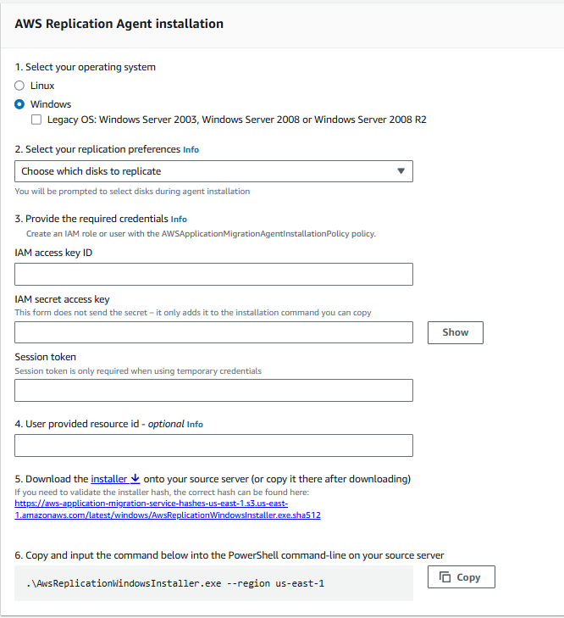

Here you can see you server ready for disk replication
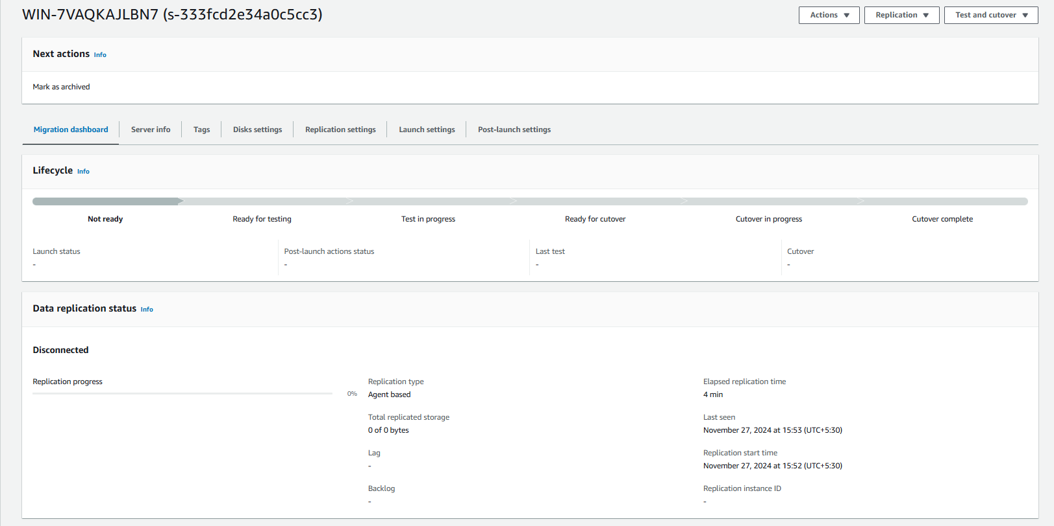
Further process it comes after replication of disk completed

3.5: Replication - Launch test instance to finalise cutover

3.5.1: Create or Edit a Launch Template:
- Create New or Edit Existing:
  - If you do not have a launch template, you will need to create one. If a template exists, click Edit to modify it.
- Configure General Launch Settings:
  - Start instance upon launch: Enable this option if you want the instance to start automatically after launching.
- Transfer server tags:
  - Choose whether to transfer tags from the source server to the launched instance.
- Bring your own license:
  - Specify if you want to bring your own license for software on the instance.
- Configure EC2 Launch Template Settings:
  - Default Target Subnet: Specify the subnet where instances will be launched. Ensure that this subnet is valid and accessible.
  - Security Group: Optionally, add a security group to control inbound and outbound traffic for your instances.
  - Instance Type: Choose the instance type for your launched instance suggested by discovery agent else turn on instance right sizing in launch template.
  - EBS Volume Types and Performance Settings: Adjust settings such as IOPS and throughput as needed for performance requirements.

3.5.2: Verify Launch Template:
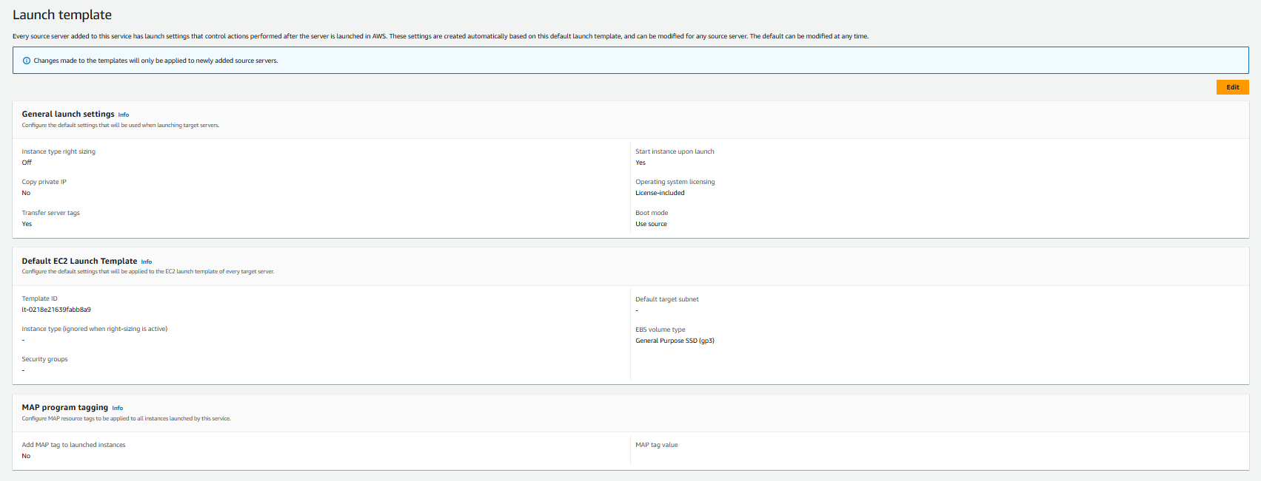After saving, verify that the launch template settings are correctly applied by navigating back to the source servers section and checking the launch settings for any added servers.

3.5.3: Launch test instance:
With the desired source server selected, click on Launch test instance.
Confirm that you want to proceed with launching a test instance based on your configured launch template settings. With the desired source server selected, click on Launch test instance.
Test all the application and services which migrated from on-prem to aws ec2 within launched test instance only.

3.5.4: Transitioning from Test Instance to Cutover Instance:
- Launch Cutover Instance
  - In the AWS Application Migration Service console, go to Source servers and select the source server that you previously tested.
  - Confirm that you want to proceed with launching a cutover instance based on your configured launch template settings.
- Automatic Clean-up:
  - AWS Application Migration Service will automatically delete any previously launched test instances and dependent resources before launching the new cutover instance. This ensures that the cutover instance reflects the most up-to-date state of the source server.

3.5.4: Finalize Cutover:
- Finalize Cutover:
  - Once you have confirmed that the cutover instance is functioning correctly, navigate back to the source server details.
  - Select Finalize cutover to complete the migration process for this server.
- Complete Migration Lifecycle:
  - Upon finalizing, the source server's migration lifecycle status will change to Cutover complete, indicating that the migration has been successfully performed.
  - Data replication will stop, and all replicated data will be discarded. AWS resources used for data replication will also be terminated.

5.0 Annexure - I

Information / content of Annexure - I and so on…

[ SOPs are used to document many types of processes, while runbooks are typically used to document IT-specific tasks.
SOPs may also include contextual information and multiple processes, while runbooks typically cover one process. ]

